Group 19

CSE-A

Jaya Ganesh Kumar - AP19110010007

Akash Reddy Narala - AP19110010018

Sai Sri Ram Kumar Macha - AP19110010138

**Title:**

Blood Bank Management System

**Aim:**

We aim to develop a web application that can manage some of the operations in a blood bank.

**Abstract:**

It is a user to user interactive web application. Basic login details are encrypted with some hash algorithm. For the donor, his/her details i.e. name, mobile number, age, blood group, diseased recently, etc. For the patient, we will display the details of the available donors in the city they chose.

**Technologies used:**

* Front end: HTML, CSS, JS.
* Middleware: PHP.
* Backend: SQL.

**Software Requirements** :

The Latest Version of PHP and MySQL software and the Latest Version of any web Browsers is Highly recommended. Whereas any web browser with JavaScript enabled and any stable versions of PHP and MySql are the minimum requirement.

**Details Handled :**

1. Basic login details like user ID and Password are handled with at most security.
2. For a donor, his/her details i.e., name, blood group, location, etc.
3. For patients, he will be asked to fill in the details of the donor from whom he got blood.

**Who can use this application in real life:-**

1. IN real-life situations, anyone who wants to donate or request blood can use this application.

**Algorithm:**

1. On the home page, the user will be asked to register if he is not a customer and will be asked to log in if he already registered.
2. After he logins, he will be redirected to the user page to choose to donate or request blood.
3. In donate plage, he will be asked to fill in the details like name, father’s name, blood group, mobile number, etc.
4. If he wants to request blood, then he can choose the request option and on a separate page, he can choose his city and can find all the available donors with their mobile numbers and blood group.

**SQL Sample Images:**







**End-User Preview:  
  
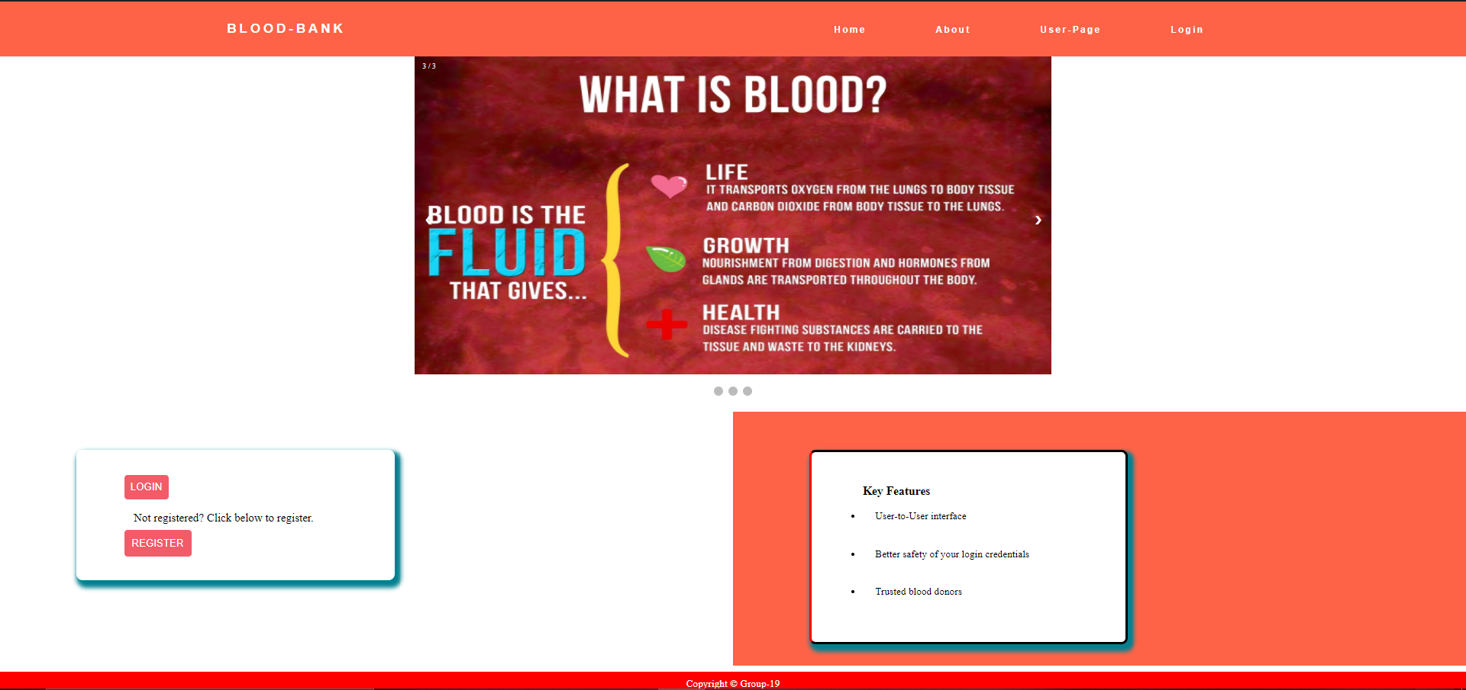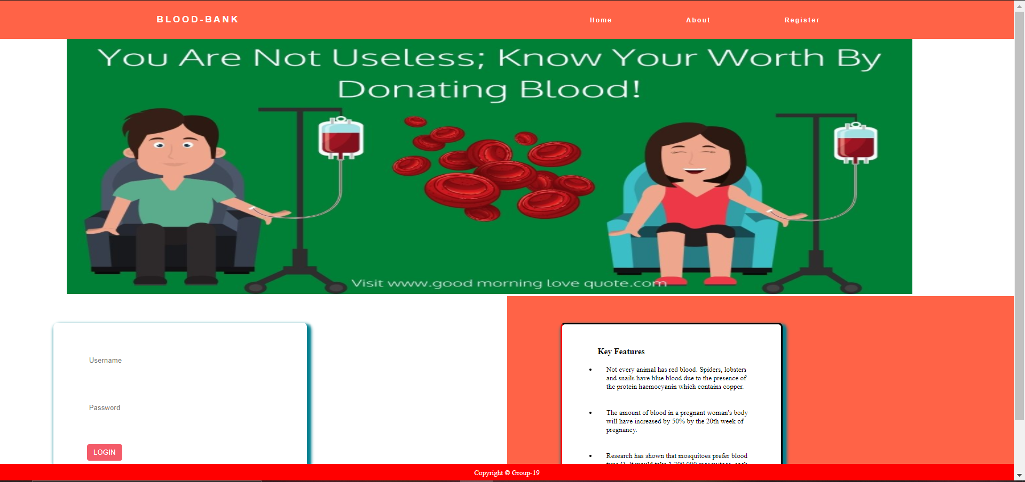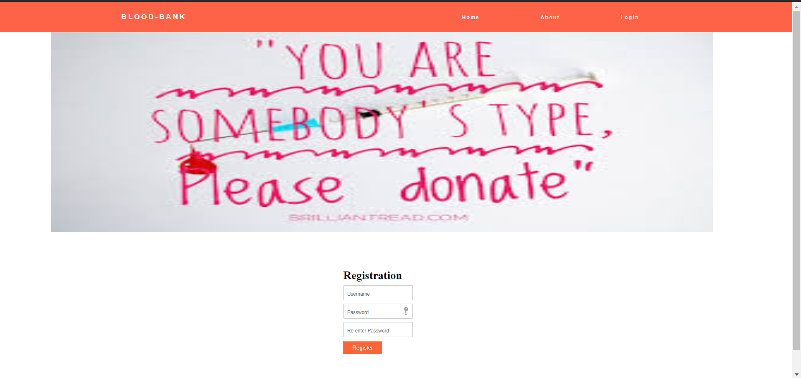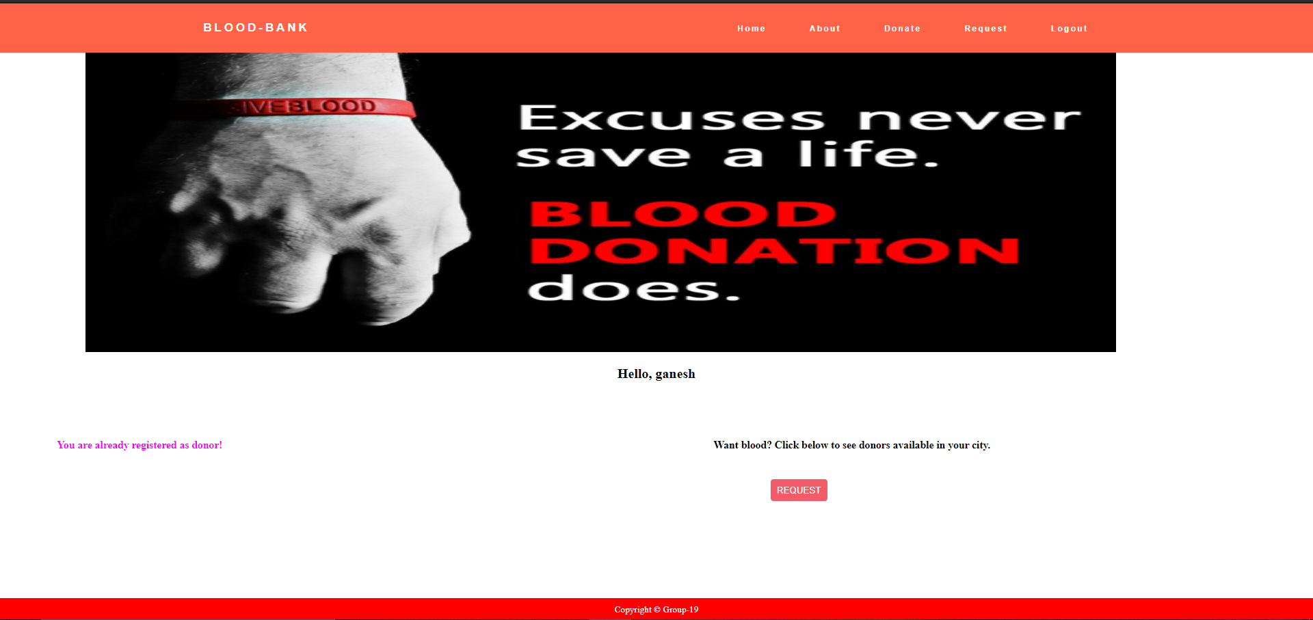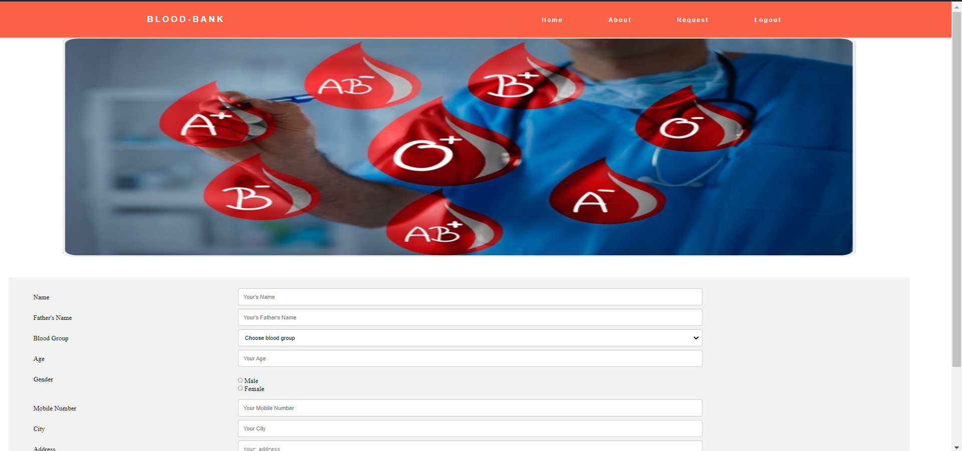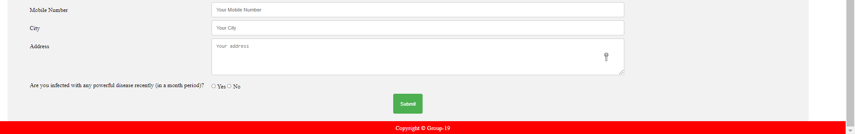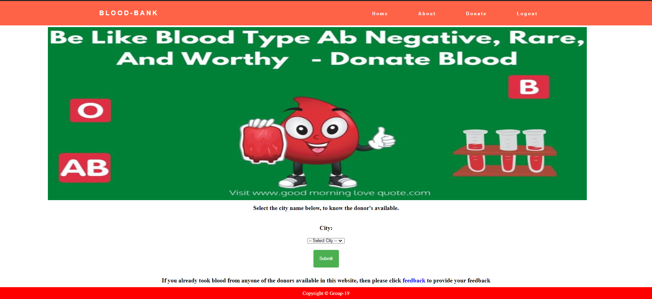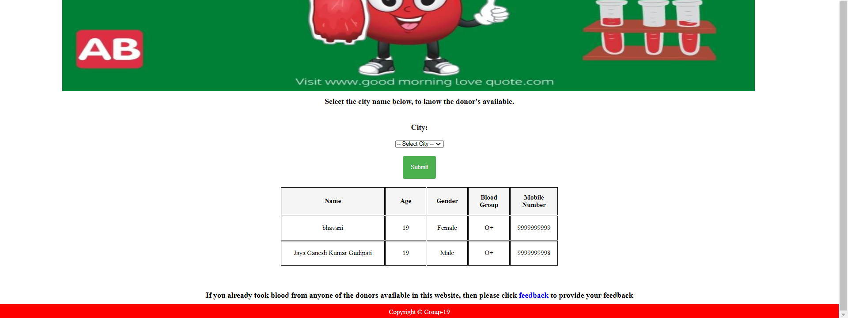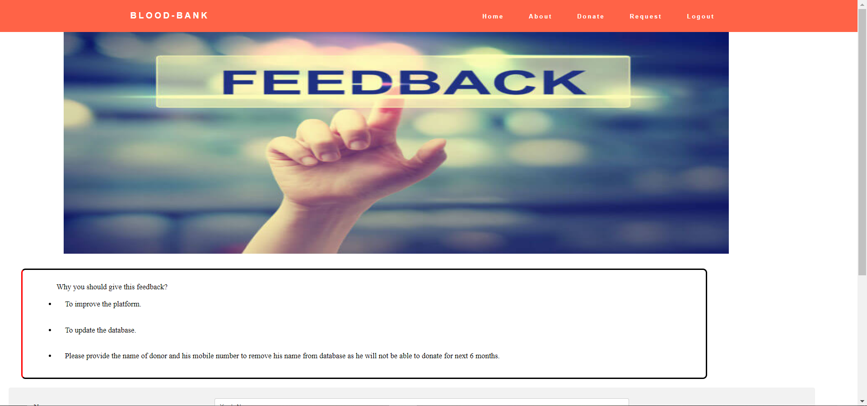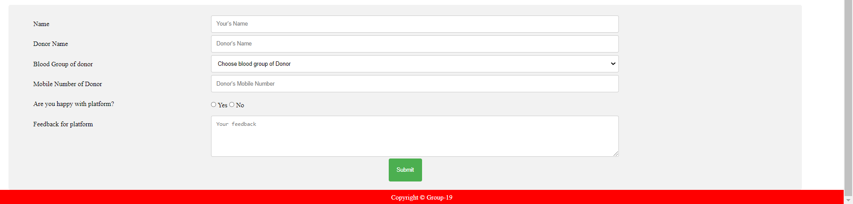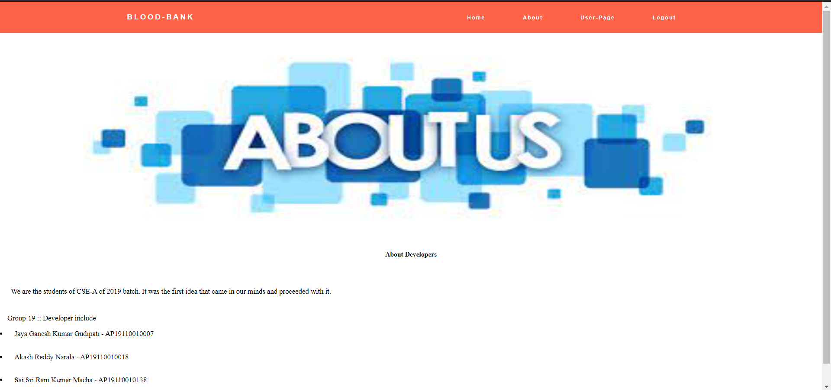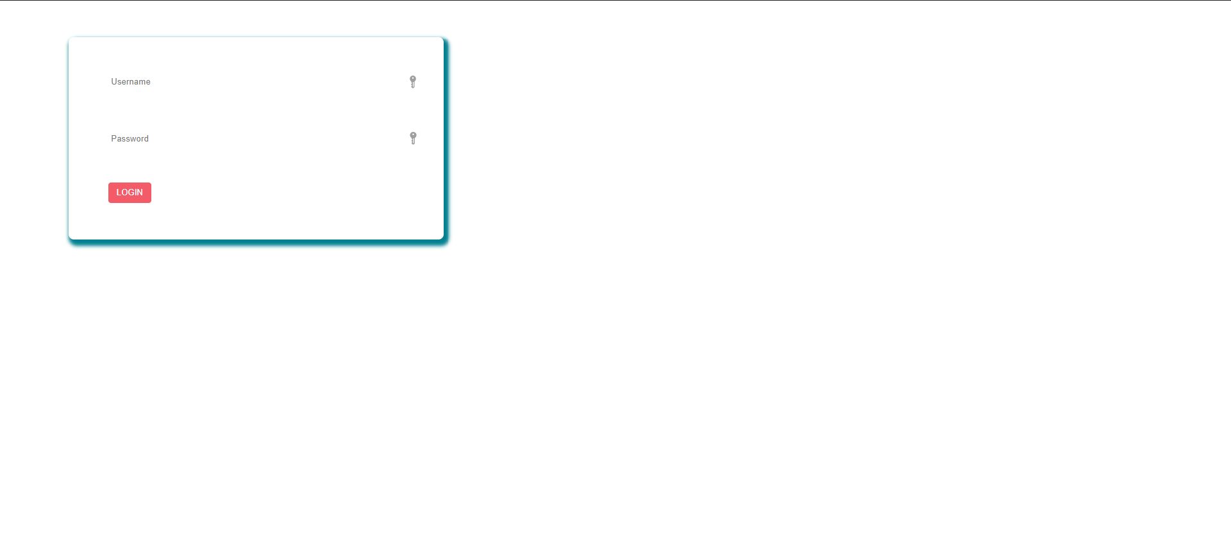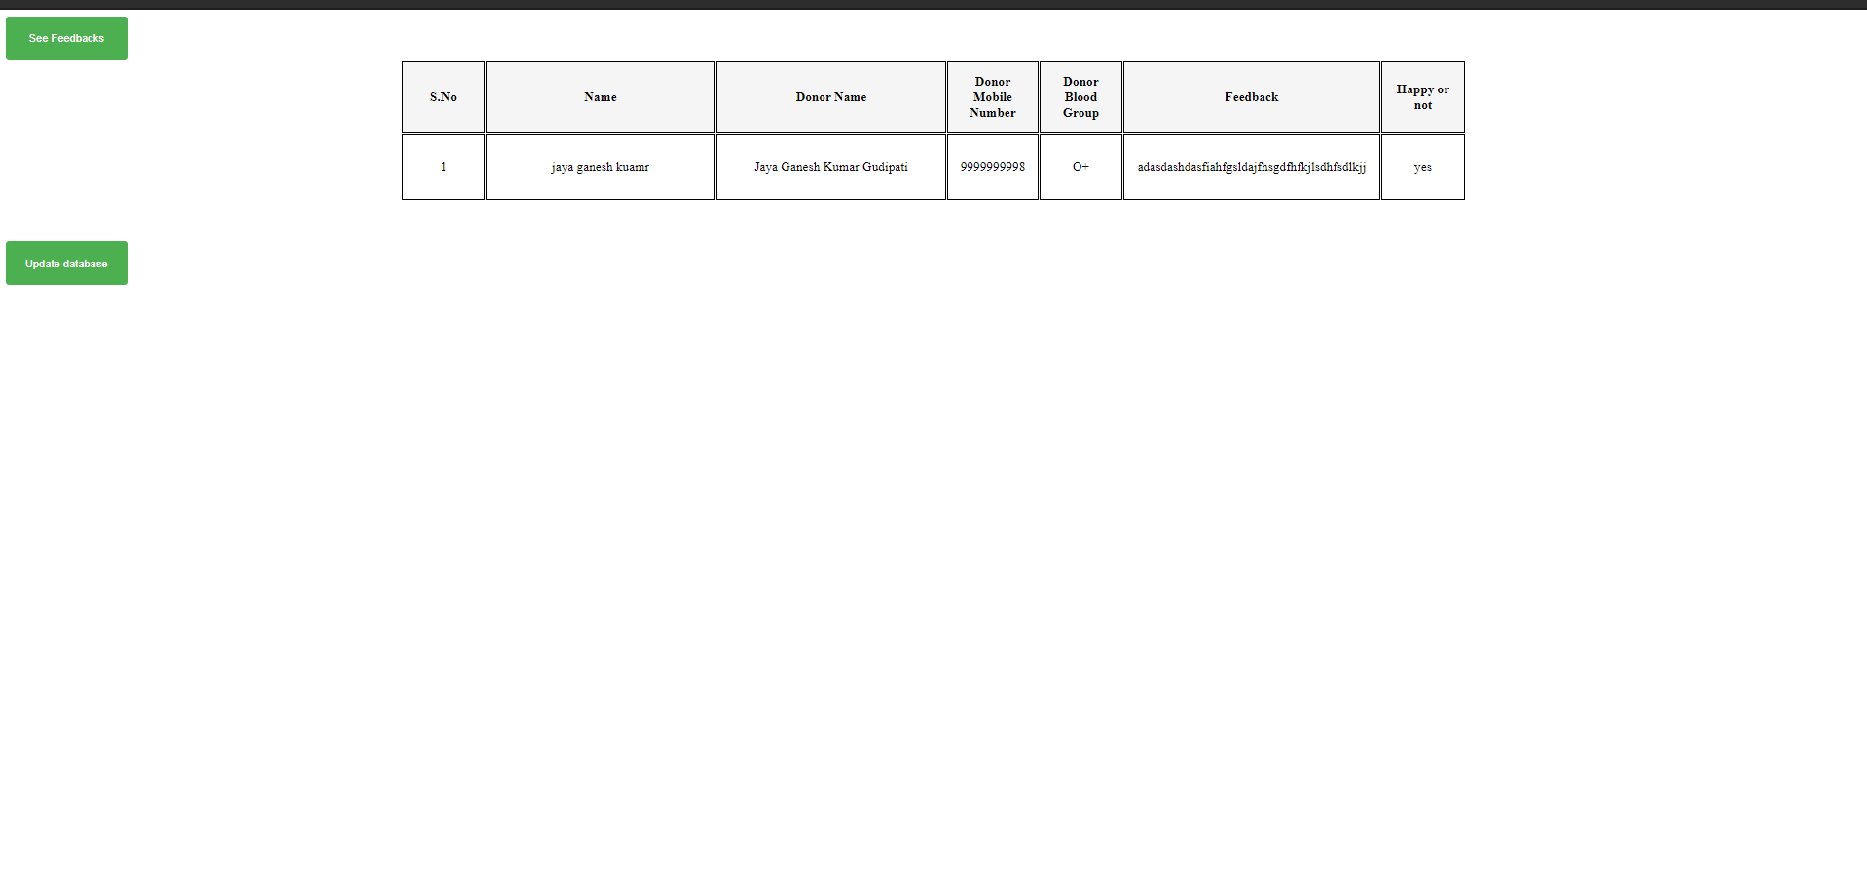**

**Conclusion:**

The User will have a smooth experience while using the website due to page linking and user-friendly UI using CSS. The user critical information such as passwords are hashed (md5 algorithm) and stored securely in the database. The website has a neat sorting page where the user can sort for donors with respect to their location.